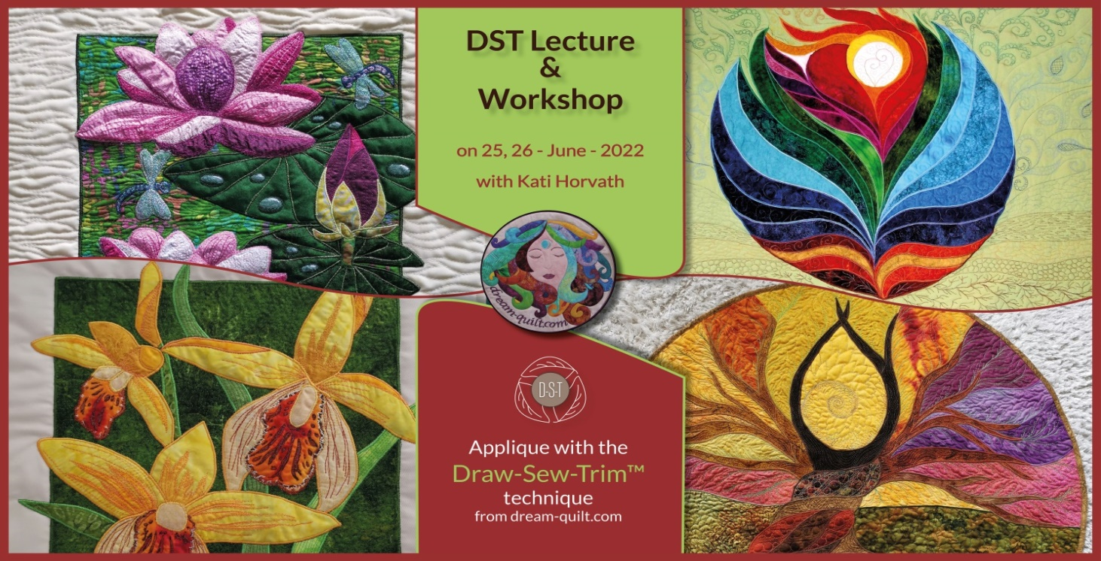

**Bookings to Jenny Crossland, 4 Herschell Road, Exeter EX4 6LX** [**jennycrossland@gmail.com**](mailto:jennycrossland@gmail.com)

**Telephone enquiries to Mary Parsons 07496 867 843**

**Draw-Sew-Trim Workshop**

with Katalin Horvath

**Sunday 26th June 2022**

**Exton Village Hall, Station Rd, Exton, Exeter EX3 0PS**

**From 10 am to 4pm**

**Cost £30 members, £33 non-members**

Katalin is offering a workshop on her technique of Draw, (she will provide a drawn pattern) and show us her Sew and Trim method. Kati’s says her method will transform how you do appliqué. She uses a lot of variation in colour tones and a variety of colours. Please see pictures to see patterns offered, they are Orchid Flower, Lotus Flower, or Mandalas - Sunrise or Flow.

Kati is offering kits, if required but these need to be ordered before the workshop.

Please check her website for what they look like and for more information.

<https://www.dream-quilt.com/patterns-1>