

**Saturday 25th June 2022**

**Colyford Memorial Hall, Swan Hill Rd, Colyford, Colyton EX24 6QJ 10 am to 4 pm**

Cost £12:00 for members, £14:00 for non-members in advance.

£2 extra for payment on the day, if fire regulations not compromised by numbers

**South West Quilters**

**Summer Day Meeting**

Afternoon Speaker - Katalin Horvath

**“The Draw-Sew-Trim applique technique.”**

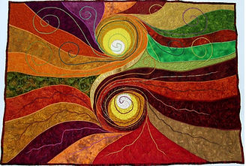

Morning Speaker – Louise Nichols

**“From Graduation to a Career as a Textile Artist”**

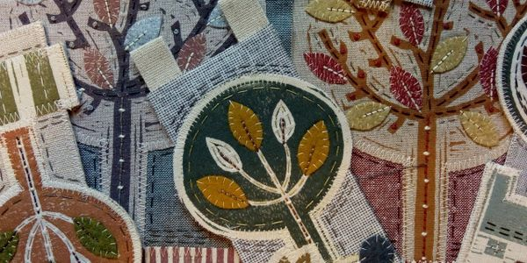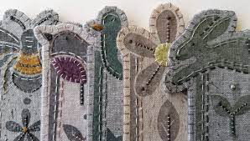

Quilt Raffles for Different Charities - Please bring your own refreshments

Traders:

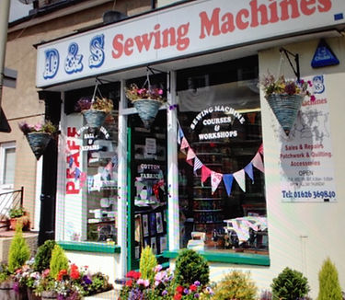

Plus, our own Sunset Trust Table